**Nasa Space APPS Challenge**

**Moron.**

**Challenge: “Wildfire Busters”**

**A fire tracking tool**

**Team: UM Challengers 2020**

Members: Paula Galletti, Cecilia Zalazar, Clara Cordenons, Ezequiel Romanelli, Uriel Sánchez y María de los Ángeles Fischer. Interdisciplinary group of University of Morón.

**Title:**

**WILDFIRE BUSTERS: A fire tracking tool for global wildfire control and mitigation**

**Summary:**

Wildfires cause negative effects around the world. Therefore, we consider that victims and decision makers need to have real-time information of wildfires evolution and their probable impact. In this sense, our main objective is to create an application that offer information to users about the minimum distance to hotspots and its properties (location, detection time, fire energy power, reliability, fire event condition) and information about fuel, landscape characteristics, wildfires history behavior, weather conditions and potential impacts. In turn, users could enrich the application with their knowledge of area. The application can be a great help, for the development of fire mitigation strategy as well as in the implementation of policies before, during and after the environmental disaster.

**Describe how your project addresses this challenge**

A fire is a violent oxidation process that begins with the presence of a fuel, the oxidizer (oxygen) and the heat or activation energy. When this process is not controlled affecting undesirable thing, it becomes a fire. Currently, a large part of terrestrial ecosystems is affected by fires, altering their structure, composition or functioning (Di Bella et al. 2006, Fischer et al. 2010, Di Bella et al. 2011, Albanesi et al. 2014). These events cause, for example, reduction and damage of vegetation cover, deaths of people or animals (Moeltner et al. 2013, Jhariya et al. 2014), even changes in the water cycle, nutrients or energy balance (González-Pérez et al. 2004). That alterations with catastrophic consequences for ecosystem level (Komareck 1964, Crutzen and Andrade 1990, Mueller-Dombois and Goldamer 1990, González-Alonso et al. 1996, 1997 and 1998, Houghton et al. 1999, Jenkins et al. 2001 and 2003, Nabuurs et al. 2007, Chen et al. 2011, McDaniel 2008, Fagan and DeFries 2009, Pausas and Keely 2014, Sommers et al. 2014, Huang et al. 2015).

However, the negative effects of fires were largely ignored in history. In fact, fires were generally considered natural events, so large areas were wildly affected by fires every year during decades. With the growing eagerness to protect and conserve natural resources and ecosystems services, the need to study wildfires has grown over the past years. In consequence, scientist community began to analyze fires and their relation with environmental factors along history. In fact, South America was identified as a region of concern due to human trigger factors outweigh climatic drivers for wildfire occurrence. In this sense, the probability to predict fire occurrence decreases due to the increase in anthropic factors and their randomness. Humans burns by multiple reasons. For example, a large part of the fires in livestock production systems is associated with the need to reduce dry plant biomass and promote the regrowth of vegetation for feed livestock. Likewise, man burns for coverage reduction in order to change land cover choosing agriculture. In addition, man-made fires due to accidental causes should be considered. Therefore, in order to detect and predict the anthropic trigger factor it is very difficult, so in this project it is proposed to analyze the fires danger once started.

Currently, satellite information offers an unparalleled opportunity to study fire events along large surfaces with great objectivity and high temporal frequency (Di Bella et al. 2006, Fischer et al. 2012, 2015). There is a lot of information allowing the analysis of active hotspots throughout the world hourly (Giglio et al. 2003, Justice et al. 2002), as well as having meteorological information, fuel coverage, among others. Clustering such information together to make it user-friendly is essential to provide the important data for decision-making.

In this sense, the main objective of this group is to create an application that offer information to users about the minimum distance to hotspots and its properties (location, detection time, fire energy power, reliability, fire event condition) and information about fuel, landscape characteristics, wildfires history behavior, weather conditions and potential impacts.

In turn, we consider that this application has a mode for information upload by users, being them who can adjust certain indices for their area of ​​influence. This information can be seen by other users but not altering the original index calculated by our team. This kind of feedback could enrich the application by adding in situ data, not available actually.

**Describe how you developed your project**

Fires are very frequent extreme events that cause negative effects in a large part of the ecosystems (Chuvieco 2000). Around the world last week more than 126 thousand hotspots (FIRMS NASA) were detected by only MODIS sensor, equivalent to a potential area of 126,000 km2. In addition, in Argentina more than 10 provinces area affected by fire events nowadays.

Therefore, we consider that victims and decision makers need to have real-time information of wildfires evolution and their probable impact. In order to board this, our main objective was to create an application for mobile devices that offers users the ability to identify active fire hotspots, providing information about the surrounding areas and the danger of fire reaching them. For this, we considered several features: meteorology (wind speed and direction), quantity and state of the fuel (integral of the vegetation indices during the previous growing season and its level of fall before the fire), physical aspects of the landscape such as topography (slope and orientation) and the presence of physical barriers (routes, firebreaks, water courses, etc.), and the fire history as behavior and frequency of fires and their impacts. In addition, we also considerer information about protected areas. From this data the application provides a fire event score with 5 classes from least harmful to very harmful.

The application also offers to users the option to change the weight of some of variables in a module visible by other people but not changing our original score. The goal is that module fed by in situ user’s knowledge but not altering the original ranking module.

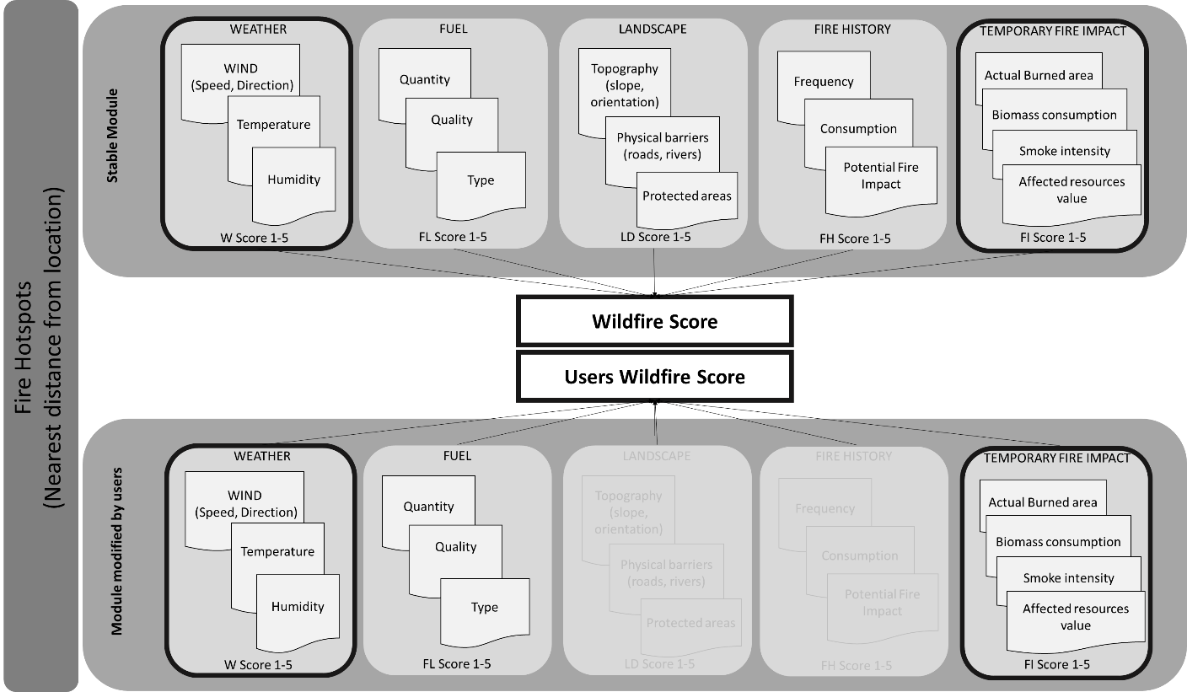

The prototype or mockup will be generated using Balsamig Mockups. For the development of the application, the Android Studio Framework will be used, using JAVA language, having a module that contains all the requirements of the application.

In order to define the people reached by our project, the application will have two different targets with two different communication strategies will be proposed. The first target is mainly oriented towards those who are part of the agribusiness, environment and sustainable development and social development team. It is also aimed at government decision-makers (governors, mayors, deputies and senators). Our application can be of great help for the development of the fire mitigation strategy as well as in the creation and implementation of policies, both social and economic, before, during and after the environmental disaster.

At the beginning of the communication strategy for this target, it will seek to contact the Ministry of the Environment and Sustainable Development of the Argentine Nation. At the same time, other government decision-makers will also be contacted, starting with the secretaries of the environment and sustainable development of different municipalities. On a global scale, one must first investigate which government agencies are dealing with the fire problem in their respective countries.

In Argentina, the Ministry of Environment and Sustainable Development covers the problem of fires and for this it has a Fire Alert and Prevention area which developed four important points:

1. Hazard assessment and early warning.
2. Fire report.
3. Fire management.
4. Prevention.

The application can be a great help in these four stages, because it predicts how fires will develop and helps their early detection.

The second target would be the common citizen. Men and women from 18 to 50 years old, middle class, upper middle class and upper class. People with a university education level and / or professional training. All people who have a mobile device or smartphone and access to the network. Those who are interested in nature, climate change, preservation of the environment, ecology and sustainable agricultural production.

As part of the communication strategy, we will highlight the concept of fire detection and control and mitigation measures. The massive campaign will be guide to social networks, radio and television. The different pieces of communication will seek to generate an impact by emphasizing the impact of fires in the country and in the world, encouraging the download of the application as the main ally for the prevention, control and mitigation of this type of event.

**How did you use space agency data in your project?**

The application used inputs data providing by Space Agencies around the world and free and open data available in order to address features influencing fire propagation and impact. The following table shows the data and the sources of information consulted to address the issues:



**References**

Background references

* Albanesi S., Dardanelli S., Bellis L.M. 2014. Effects of fire disturbance on bird communities and species of mountain Serrano Forest of Central Argentina. Journal of Forest Research 19: 105-114.
* Chen X., Liu S., Zhu Z., Vogelmann J., Li Z., Ohlen D. 2011. Estimating aboveground forest biomass carbon and fire consumption in the U.S. Utah High Plateaus using data from Forest Inventory and Analysis Program, Landsat, and LANDFIRE. Ecological Indicators 11, 140-148.
* Chuvieco E., 2000. Remote Sensing of Forest Fires. Observing Land from Space: Science, Customers and Technology. Advances in Global Change Research 4, 47-51.
* Crutzen P.J., Andrade M.O. 1990. Biomasa burning in the tropics: Impact on atmospheric chemistry and biogeochemical cycles". Science 250, 1669-1678.
* Di Bella C.M., Fischer M.A., Jobbágy E.G. 2011. Fire patterns in northeastern Argentina: influences of climate and land use/cover. International Journal of Remote Sensing 32: 4961-4971.
* Di Bella C.M., Jobbágy E.G., Paruelo J.M., Pinnock S. 2006. Continental fire density in South America. Global Ecology and Biogeography 15 (2): 192-199
* Di Bella C.M., Posse G., Beget M.E., Fischer M.A., Mari N., Veron S. 2008. La teledetección como herramienta para la prevención, seguimiento y evaluación de incendios e inundaciones. Ecosistemas 17(3):39-52.
* Fagan M., DeFries R. 2009. Measurement and Monitoring of World's Forests. A review and summary of remote sensing technical capability, 2009-2015. RFF REPORT. (available at http://www.rff.org/rff/documents/rff-rpt-measurement%20and%20monitoring.pdf, July 2012).
* Fischer, M.A., Di Bella, C.M., Jobbágy, E.G. 2012. Fire patterns in central semiarid Argentina. International. Journal of Arid Environments 78: 161-168.
* Giglio L., Descloitres J., Justice C.O., Kaufman Y.J. 2003. An enhanced contextual fire detection algorithm for MODIS Remote Sensing of Environment 87, 273-282 http://dx.doi.org/10.1016/S0034-4257(03)00184-6
* González-Alonso F. 1998. Aplicaciones de la teledetección espacial en la lucha contra incendios forestales. Laboratorio de Teledetección, CIFOR-INIA, Ministerio de Ciencia y Tecnología, Madrid, España.
* González-Alonso F., Cuevas J.M., Casanova J.L., Calle A., Illera P. 1996. A forest fire risk assessment using NOAA AVHRR images in the Valencia area, eastern Spain. Laboratorio de Teledetección, CIT-INIA, Madrid, España.
* González-Alonso F., Cuevas J.M., Casanova J.M., Calle A., Illera P. 1997. A forest fire risk assessment using NOAA-AVHRR images in the Valencia area, eastern Spain. International Journal of Remote Sensing 18 (10), 2201-2207.
* González-Pérez J.A., González-Vila F.J., Almendros G., Knicker H. 2004. The effect of fire on soil organic matter-a review. Environment International 30, 855– 870.
* Houghton R.A., Hackler J.L., Lawrence K.T. 1999. The U.S. carbon budget contributions from land-use change. Science 285, 574–578.
* Huang S., Liu H., Dahal D., Jin S., Welp L., Liu J., Liu S. 2013. Modeling spatially explicit fire impacto n gross primary production in interior Alaska using satellite images coupled with Eddy covariance. Remote Sensing of Environments 135, 178-188.
* Jenkins J.C., Birdsey R., Pan Y., 2001. Biomass and NPP estimation for the midatlantic region (USA) using plot-level forest inventory data. Ecological Applications 11 (4), 1174–1193.
* Jhariya M., Raj Dr, Gandhi I., Viswavidyalaya K. 2014. Effects of wildfires on flora, fauna and physico-chemical properties of soil-An overview. Journal of Applied and Natural Science. 6. 887-897.
* Justice C.O., Giglio L., Korontzi S., Owens J., Morisette J.T., Roy D., et al. 2002. The MODIS fire products. Remote Sensing of Environment 83, 244-262.
* Komarek E.V. 1964. The natural history of lightning. In: Proceedings, 3rd annual Tall Timbers fire ecology conference; 1964 April 9-10; Tallahassee, FL. Tallahassee, FL: Tall Timbers Research Station: 139-183.
* Mc Daniel J. 2008. Wildfire and the Global Carbon Cycle. Advances in Fire Practice, Wildland Fire Lessons Learned Center (available at http://www.wildfirelessons.net/AFP.aspx , July 2012).
* Moeltner K., Kim M.K., Zhu E., Yang W. 2013. Wildfire smoke and health impacts: A closer look at fire attributes and their marginal effects. Journal of Environmental Economics and Management, 476–496. DOI-10.1016/j.jeem.2013.09.004.
* Mueller-Dombois D., Goldamer J.G. 1990. FIRE in tropical ecosystems and global enviromental change: an introduction. En: Fire in tropical biota. Ecosystem processes and global challenges, J.G. Goldamer (ed.) 1:1-10.
* Nabuurs G., Masera O., Andrasko K., Benitez-Ponce P., Boer R. (et al.) 2007. Forestry. In: Metz, B., Davidson, O.R., Bosch, P.R. Dave, R., Meyer, L.A. (Eds.), Climate Change 2007: Mitigation. Contribution of Working Group III to the Fourth Assessment Report of the Intergovernmental Panel on Climate Change, Cambridge University Press, Cambridge, United Kingdom/New York, NY, USA, p 564.
* Pausas J.G., Keeley J.E. 2009. A Burning Story: The Role of Fire in the History of Life. BioScience 59: 593–601.

Satellite data sources:

Weather conditions:

Wind:

- Satellite: Goddard Earth Observing System Model, Version 5 (GEOS-5). MERRA Proyect.

- Spatial resolution: 0, 5 x 0,625°.

- Temporal resolution: Hourly.

- Source: GIOVANNI.

https://giovanni.gsfc.nasa.gov/giovanni/#service=TmAvMp&starttime=&endtime=&variableFacets=dataFieldMeasurement%3AWind%20Velocity%3B

Temperature:

- Satellite: GCOM-W.

- Sensor: AMSR.

- Spatial resolution: 11 km.

- Temporal resolution: Daily.

- Source: AMSR (Earth Environment Viewer).

https://www.eorc.jaxa.jp/AMSR/viewer/index.html

Humidity:

- Satellite: GCOM-W.

- Sensor: AMSR.

- Spatial resolution: 11 km.

- Temporal resolution: Daily.

- Source: AMSR (Earth Environment Viewer).

https://www.eorc.jaxa.jp/AMSR/viewer/index.html

Fuel conditions:

- Satellite: Sentinel 2.

- Sensor: Landsat and SWIR.

- Spatial resolution: 5km.

- Temporal resolution: daily.

- Source:

NDVI: https://www.eorc.jaxa.jp/JASMES/SGLI_STD/

SWIR 2: https://apps.sentinel-hub.com/sentinel-playground/?source=S2&lat=40.46296978223787&lng=-3.8068771082907915&zoom=11&preset=93-SWIR-2-11-12&layers=B01,B02,B03&maxcc=22&gain=1.0&gamma=1.0&time=2020-03-01%7C2020-09-30&atmFilter=&showDates=false

Landscape conditions:

Topography:

- Satellite: Sentinel 2.

- Sensor: Landsat.

- Spatial resolution: 250 m.

- Temporal resolution: Monthly.

- Source: https://earthexplorer.usgs.gov/

Physical barriers:

- Satellite: VIIRS.

- Spatial resolution: 375 m.

- Temporal resolution: Daily.

- Source: https://firms2.modaps.eosdis.nasa.gov/map/#d:2020-10-02..2020-10-03;l:countries;@-47.4,-31.0,6z

Protected areas:

- Satellite: VIIRS and Terra/Aqua.

- Espatial resolution: 375 m.

- Temporal resolution: Daily.

- Source: https://firms2.modaps.eosdis.nasa.gov/map/#d:2020-10-02..2020-10-03;l:protected_areas,viirs_crtc;@-42.9,-27.6,4z

Fire history

Fire emissions:

- Satellite: Terra and Aqua.

- Sensor: MODIS.

- Espatial resolution: 500 m.

- Temporal resolution: 2003-2016 (annually).

- Source: Global Fire Emissions Database.

https://www.globalfiredata.org/fireatlas.html

Burnt areas:

- Minisatellite: PROBA- V.

- Sensor: PROBA-V.

- Spatial resolution: 300 m.

- Temporal resolution: Every 3 days.

- Source: Copernicus Global Land Services→ Burnt Areas Map. https://land.copernicus.vgt.vito.be/PDF/portal/Application.html#Browse;Root=513584